**Part 1: SDG Selection and Problem Definition**

1. **SDG Selection**:
   * **SDG 3: Good Health and Well-Being** focuses on ensuring healthy lives and promoting well-being for all at all ages.
2. **Problem Definition**:
   * **Problem**: In many rural areas, vaccination rates are low due to limited access to healthcare services. This project will focus on tracking vaccination coverage and identifying areas where additional healthcare resources are needed to improve access.
   * **Objective**: Develop a data-driven solution to monitor vaccination rates, identify gaps in coverage, and provide insights to healthcare providers for better resource allocation.

**1. Entities and Attributes**

* **Location**
  + **LocationID (Primary Key)**
  + **LocationName**
  + **Address**
  + **Region**
  + **ProviderID (Foreign Key)**
* **Provider**
  + **ProviderID (Primary Key)**
  + **ProviderName**
  + **ContactInfo**
  + **LocationID (Foreign Key)**
* **Vaccine**
  + **VaccineID (Primary Key)**
  + **VaccineName**
  + **VaccineType**
  + **Manufacturer**
* **Vaccination**
  + **VaccinationID (Primary Key)**
  + **PatientID (Foreign Key)**
  + **VaccineID (Foreign Key)**
  + **ProviderID (Foreign Key)**
  + **DateAdministered**
* **Appointment**
  + **AppointmentID (Primary Key)**
  + **PatientID (Foreign Key)**
  + **ProviderID (Foreign Key)**
  + **DateScheduled**
  + **DateCompleted**
* **Visit**
  + **VisitID (Primary Key)**
  + **PatientID (Foreign Key)**
  + **DateOfVisit**
  + **LocationID (Foreign Key)**
* **Patient**
  + **PatientID (Primary Key)**
  + **FirstName**
  + **LastName**
  + **DateOfBirth**
  + **ContactInfo**
  + **Address**

**2. Relationships**

* **Location to Provider: Each Provider is associated with one Location.**
* **Provider to Vaccine: Each Provider can administer multiple Vaccines.**
* **Patient to Vaccination: Each Patient can have multiple Vaccinations.**
* **Vaccination to Vaccine: Each Vaccination involves one Vaccine.**
* **Vaccination to Provider: Each Vaccination is administered by one Provider.**
* **Patient to Appointment: Each Patient can have multiple Appointments.**
* **Appointment to Provider: Each Appointment is scheduled with one Provider.**
* **Patient to Visit: Each Patient can have multiple Visits.**
* **Visit to Location: Each Visit occurs at one Location**

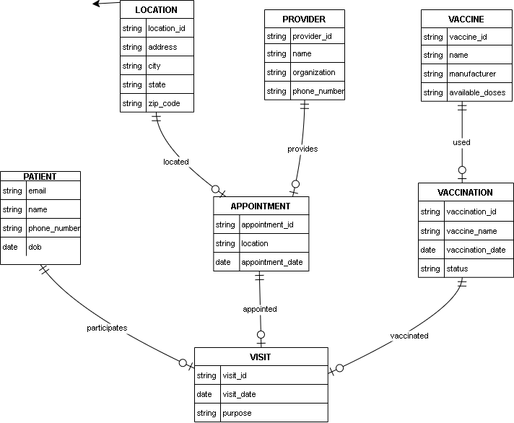

**PART 3: SQL SCRIPTS**

CREATE TABLE Location (

LocationID INT PRIMARY KEY,

LocationName VARCHAR(255),

Address VARCHAR(255),

Region VARCHAR(100),

ProviderID INT,

FOREIGN KEY (ProviderID) REFERENCES Provider(ProviderID)

);

CREATE TABLE Provider (

ProviderID INT PRIMARY KEY,

ProviderName VARCHAR(255),

ContactInfo VARCHAR(255),

LocationID INT,

FOREIGN KEY (LocationID) REFERENCES Location(LocationID)

);

CREATE TABLE Vaccine (

VaccineID INT PRIMARY KEY,

VaccineName VARCHAR(255),

VaccineType VARCHAR(100),

Manufacturer VARCHAR(255)

);

CREATE TABLE Vaccination (

VaccinationID INT PRIMARY KEY,

PatientID INT,

VaccineID INT,

ProviderID INT,

DateAdministered DATE,

FOREIGN KEY (PatientID) REFERENCES Patient(PatientID),

FOREIGN KEY (VaccineID) REFERENCES Vaccine(VaccineID),

FOREIGN KEY (ProviderID) REFERENCES Provider(ProviderID)

);

CREATE TABLE Appointment (

AppointmentID INT PRIMARY KEY,

PatientID INT,

ProviderID INT,

DateScheduled DATE,

DateCompleted DATE,

FOREIGN KEY (PatientID) REFERENCES Patient(PatientID),

FOREIGN KEY (ProviderID) REFERENCES Provider(ProviderID)

);

CREATE TABLE Visit (

VisitID INT PRIMARY KEY,

PatientID INT,

DateOfVisit DATE,

LocationID INT,

FOREIGN KEY (PatientID) REFERENCES Patient(PatientID),

FOREIGN KEY (LocationID) REFERENCES Location(LocationID)

);

CREATE TABLE Patient (

PatientID INT PRIMARY KEY,

FirstName VARCHAR(255),

LastName VARCHAR(255),

DateOfBirth DATE,

ContactInfo VARCHAR(255),

Address VARCHAR(255)

);

**1. Insert Sample Data**

**Location**

sql

INSERT INTO Location (LocationID, LocationName, Address, Region, ProviderID)

VALUES

(1, 'Central Health Clinic', '123 Main St, Nairobi', 'Nairobi', 1),

(2, 'Westside Health Center', '456 Elm St, Nairobi', 'Nairobi', 2);

**Provider**

sql

INSERT INTO Provider (ProviderID, ProviderName, ContactInfo, LocationID)

VALUES

(1, 'Dr. Jane Doe', '555-1234', 1),

(2, 'Dr. John Smith', '555-5678', 2);

**Vaccine**

sql

INSERT INTO Vaccine (VaccineID, VaccineName, VaccineType, Manufacturer)

VALUES

(1, 'COVID-19 Vaccine', 'mRNA', 'Pfizer'),

(2, 'Flu Vaccine', 'Inactivated', 'Moderna'),

(3, 'Hepatitis B Vaccine', 'Recombinant', 'GlaxoSmithKline');

**Patient**

sql

INSERT INTO Patient (PatientID, FirstName, LastName, DateOfBirth, ContactInfo, Address)

VALUES

(1, 'Alice', 'Johnson', '1985-03-25', '555-1111', '789 Oak St, Nairobi'),

(2, 'Bob', 'Williams', '1990-07-30', '555-2222', '101 Pine St, Nairobi');

**Vaccination**

sql

INSERT INTO Vaccination (VaccinationID, PatientID, VaccineID, ProviderID, DateAdministered)

VALUES

(1, 1, 1, 1, '2024-01-15'),

(2, 2, 2, 2, '2024-02-20'),

(3, 1, 3, 1, '2024-03-10');

**Appointment**

sql

INSERT INTO Appointment (AppointmentID, PatientID, ProviderID, DateScheduled, DateCompleted)

VALUES

(1, 1, 1, '2024-01-10', '2024-01-15'),

(2, 2, 2, '2024-02-15', '2024-02-20');

**Visit**

sql

INSERT INTO Visit (VisitID, PatientID, DateOfVisit, LocationID)

VALUES

(1, 1, '2024-01-15', 1),

(2, 2, '2024-02-20', 2);

**2. Explanation**

* **Location**: Represents healthcare centers with basic information.
* **Provider**: Represents healthcare providers associated with specific locations.
* **Vaccine**: Lists different types of vaccines available.
* **Patient**: Contains patient details.
* **Vaccination**: Tracks which vaccines were administered to which patients and by which provider.
* **Appointment**: Schedules and tracks appointments between patients and providers.
* **Visit**: Logs patient visits to healthcare centers.

**4. Verify Data**

After inserting the sample data, you can run SELECT queries to verify that the data has been correctly inserted:

sql

SELECT * FROM Location;

SELECT * FROM Provider;

SELECT * FROM Vaccine;

SELECT * FROM Patient;

SELECT * FROM Vaccination;

SELECT * FROM Appointment;

SELECT * FROM Visit;

Part 3: SQL Programming Now, we'll write SQL queries to retrieve and analyze the data based on our problem definition.

**1. Data Retrieval Queries**

**a. Retrieve All Vaccinations for a Specific Patient**

To get all vaccinations received by a specific patient:

sql

SELECT

p.FirstName,

p.LastName,

v.VaccineName,

va.DateAdministered,

pr.ProviderName,

l.LocationName

FROM

Vaccination va

JOIN

Patient p ON va.PatientID = p.PatientID

JOIN

Vaccine v ON va.VaccineID = v.VaccineID

JOIN

Provider pr ON va.ProviderID = pr.ProviderID

JOIN

Location l ON pr.LocationID = l.LocationID

WHERE

p.PatientID = 1; -- Replace with the specific PatientID

**b. List All Providers and Their Associated Locations**

To get a list of all healthcare providers and the locations they are associated with:

sql

SELECT

pr.ProviderName,

l.LocationName,

l.Address

FROM

Provider pr

JOIN

Location l ON pr.LocationID = l.LocationID;

**c. Get Upcoming Appointments for a Patient**

To find all upcoming appointments for a specific patient:

sql

SELECT

a.DateScheduled,

a.DateCompleted,

l.LocationName,

pr.ProviderName

FROM

Appointment a

JOIN

Provider pr ON a.ProviderID = pr.ProviderID

JOIN

Location l ON pr.LocationID = l.LocationID

WHERE

a.PatientID = 1 -- Replace with the specific PatientID

AND a.DateScheduled > CURRENT_DATE; -- Only future appointments

**d. Count the Number of Vaccinations Administered by Each Provider**

To count how many vaccinations each provider has administered:

sql

SELECT

pr.ProviderName,

COUNT(va.VaccinationID) AS NumberOfVaccinations

FROM

Vaccination va

JOIN

Provider pr ON va.ProviderID = pr.ProviderID

GROUP BY

pr.ProviderName;

**2. Data Analysis Queries**

**a. Vaccination Rates by Vaccine Type**

To analyze the distribution of vaccination types administered:

sql

SELECT

v.VaccineName,

COUNT(va.VaccinationID) AS NumberAdministered

FROM

Vaccination va

JOIN

Vaccine v ON va.VaccineID = v.VaccineID

GROUP BY

v.VaccineName;

**b. Vaccination Coverage by Region**

To find out the number of vaccinations administered in each region:

sql

SELECT

l.Region,

COUNT(va.VaccinationID) AS NumberOfVaccinations

FROM

Vaccination va

JOIN

Provider pr ON va.ProviderID = pr.ProviderID

JOIN

Location l ON pr.LocationID = l.LocationID

GROUP BY

l.Region;

**c. Average Time Between Appointment Scheduling and Completion**

To calculate the average time between when an appointment is scheduled and when it is completed:

sql

SELECT

AVG(DATEDIFF(a.DateCompleted, a.DateScheduled)) AS AverageDays

FROM

Appointment a;

**d. Patients Who Have Received All Available Vaccines**

To find patients who have received every type of vaccine:

sql

SELECT

p.PatientID,

p.FirstName,

p.LastName

FROM

Patient p

JOIN

Vaccination va ON p.PatientID = va.PatientID

GROUP BY

p.PatientID, p.FirstName, p.LastName

HAVING

COUNT(DISTINCT va.VaccineID) = (SELECT COUNT(*) FROM Vaccine);